Jonathan Walton bio

Joint appointment: Department of Plant Biology

Education:

M.S, Plant Pathology, Cornell University

Ph.D. Biological Sciences. Stanford University

Research: Natural Products and Enzymes from Fungi

Two salient features of the Kingdom Mycota (fungi) are the synthesis of biologically active natural products and the secretion of degradative enzymes. Both have a strong impact on natural ecosystems and on human activities. Our lab studies important ecological and biotechnological aspects of both fungal natural products and fungal degradative enzymes.

Many of our most important pharmaceutical agents are derived from fungi, such as penicillin, cyclosporin, and the statins. Another important group of fungal natural products are the bicyclic peptides (amatoxins and phallotoxins) made by mushrooms in the genus*Amanita*, which account for >90% of fatal mushroom poisonings. In contrast to all other known fungal cyclic peptides, the *Amanita* toxins such as α-amanitin and phalloidin are synthesized on ribosomes instead of by nonribosomal peptide synthetases (Hallen et al., 2007). We are currently working on the biosynthetic pathway of the *Amanita* toxins. We recently showed that a dedicated enzyme in the prolyl oligopeptidase family of proteases is responsible for processing the 35-amino acid amanitin propeptide to a cyclic octapeptide (Luo et al., 2009, 2014). Two other mushrooms, *Galerina* and *Lepiota*, also synthesize α-amanitin on ribosomes as 35-amino acid propeptides.  
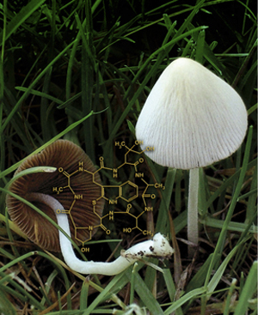

**Figure 1.** *Conocybe albipes* growing in a lawn at MSU. This mushroom makes the bicyclic peptide phalloidin (inset structure) and was used as the source to purify and identify an enzyme that processes the phalloidin precursor protein to release the linear heptapeptide of mature phalloidin (see Luo et al., 2009, 2014).

Secreted enzymes are the means by which fungi have become the dominant recyclers of carbon in all terrestial ecosystems. Building on our years of work on the role in plant pathogenesis of secreted cell-wall-degrading enzymes, such as pectinase, xylanase, and cellulase, we are now studying their biotechnological applications for biomass conversion. The focus of this work, under the auspices of the Great Lakes Bioenergy Research Center, is to identify the key enzymes for deconstruction of plant cell walls to fermentable sugars with the long-term goal of producing more efficient enzyme cocktails. Our principal strategy is to construct optimized synthetic mixtures using individual pure enzymes, statistical experimental design, and robotic liquid handling. Mixtures containing more than 18 components have been developed and shown to equal or exceed commercial “cellulase” preparations.  
  
  
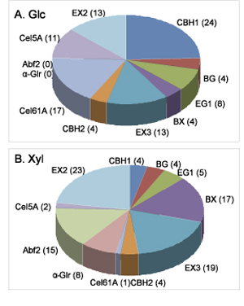

**Figure 2.**Optimized mixtures of eleven enzymes for release of Glc or Xyl from pretreated corn stover (Banerjee et al., 2010).

References:

1. Banerjee, G., S. Car, J.S. Scott-Craig, M.S. Borrusch, and J.D. Walton (2010) Rapid optimization of enzyme mixtures for deconstruction of diverse pretreatment/biomass feedstock combinations. Biotechnol. Biofuels 3:22.
2. Luo, H., S.Y. Hong, R.M. Sgambelluri, E. Angelos, X. Li, and J.D. Walton (2014) Peptide macrocyclization catalyzed by a prolyl oligopeptidase involved in α-amanitin biosynthesis. Chem Biol. 21:1610-1617. PMID: 25484237.
3. Hallen, H.E., H. Luo, J.S. Scott-Craig, and J.D. Walton (2007) A gene family encoding the major toxins of lethal *Amanita* mushrooms. Proc. Natl. Acad. Sci. U.S.A. 104:19097-19101.
4. .